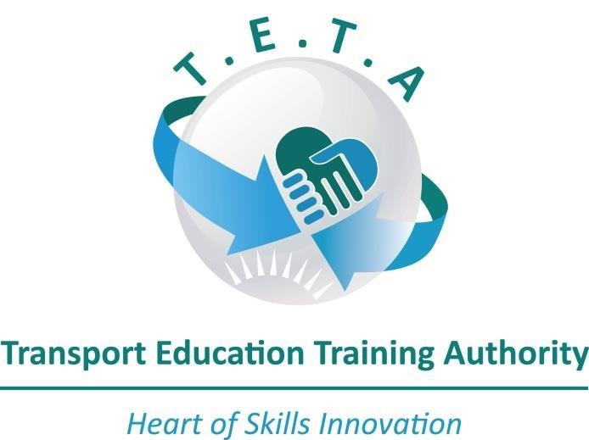

TRANSPORT EDUCATION TRAINING AUTHORITY

BURSARY GUIDELINES FOR 2019/2020 UNEMPLOYED BURSARIES APPLICATIONS
JUNE 2019

TABLE OF CONTENTS

1. WHO CAN APPLY? 2
2. ELIGIBILITY FOR A TETA BURSARY 2
3. REASONS FOR AUTOMATIC REJECTION 2
4. GUIDELINES FOR COMPLETING THE APPLICATION FORM 2
5. POSSIBLE RESEARCH TOPICS FOR POSTGRADUATES 5
6. IMPORTANT POINTS TO NOTE 5

WHO CAN APPLY?
Students that;
- Are currently in Grade 12 learners intending to study Transport-related qualifications in 2020;
- Are currently registered students at Institutions of Higher Learning (including TVET Colleges)
and require funding for the 2020 academic year;
- Have completed matric (Senior Certificate) in previous years and are currently studying or intending to study transport-related qualifications in 2020 academic year
- Commercial Pilot License- Must have a Private Pilot License
- Commercial Diving class II, III and IV should have matric (Senior Certificate)

ELIGIBILITY FOR A TETA BURSARY
Applicants must be;
- A South African citizen with a valid ID number;
- Applying for qualifications specified in the advert only;
- Students studying towards an academic qualification at an accredited institution of higher
learning;
- unemployed between 18-35 years;
- previously disadvantaged with demonstrated potential with a minimum pass mark of 50%;
- in possession of a valid Private Pilot License (PPL) when applying for Commercial Pilot Training
- in possession of a valid Commercial Pilot License when applying for Instructor’s or Instrument
Rating

REASONS FOR AUTOMATIC REJECTION
- Incorrect or incomplete application forms;
- applicants not meeting the criteria in 2 above;
- failure to submit all the required documents
- If the learner currently funded in any TETA programme or by another sponsor

GUIDELINES FOR COMPLETING THE APPLICATION FORM
Read the guidelines before completing and submitting your application form.
- Applicants should select on qualification on the application form
- Only one application form per learner
Required documents:

Grade 12/Matriculates (Prospective 1st year Students)
NB. ALL COPIES MUST BE CERTIFIED
- Certified Grade 12 Statement of Results/ Matric Certificate
- Certified ID copy of applicant;
- Certified ID copies of parents/guardian;
- Certified copy of death certificate (in case of a deceased parent/s);
- Proof of income (payslip) of parents; if unemployed affidavit is required;
- Acceptance letter from Institution of Higher Learning;
- Proof of application for study at an Institution of Higher Learning (where acceptance letter is not yet received);
- Quotations for tuition fees, accommodation etc.

TVETs (Previously known as FET Colleges)
- Certified Senior Certificate and intend to study from (N4-N6);
- Certified ID copy of applicant;
- Certified ID copies of parents/guardian;
- Certified copy of death certificate; (in case of a deceased parent);
- Proof of income (payslip) or an affidavit (if parents are unemployed);
- Acceptance letter from College;
- Proof of registration (where applicable);
- Quotations for tuition fees, accommodation etc.

Undergraduate/Postgraduate
- Certified ID copy of applicant;
- Certified copy of the highest qualification of applicant;
- Certified ID copies of parents/guardian;
- Certified copy of death certificate (in case of a deceased parent)
- Proof of income (payslip) or an affidavit (if parents are unemployed);
- Proof of application, registration or acceptance letter from Institution of Higher Learning;
- Quotations for tuition fees, accommodation etc;
- Financial Statement indicating the status quo of the learners account;

Pilot training (Commercial Pilot License)
- Certified Grade 12 Statement of Results/Matric Certificate
- Certified ID copy of applicant;
- Certified ID copies of parents/guardian;
- In case of a deceased parent, certified copy of death certificate;
- Proof of income (payslip) or an affidavit (if parents are unemployed);
- Acceptance letter or proof of registration from Aviation school;
- Certified copy of a valid Private Pilot License;
- Quotations for training costs

Pilot training (Instrument Rating)
- Certified Grade 12 Statement of Results/Matric Certificate;
- Certified ID copy of applicant;
- Certified ID copies of parents/guardian;
- In case of a deceased parent, certified copy of death certificate;
- Proof of income (payslip) or an affidavit (if parents are unemployed);
- Acceptance letter or proof of registration from Aviation school;
- Certified copy of a valid Commercial Pilot License
- Quotations for training costs

Pilot training (Instructors Rating)
- Certified Grade 12 Statement of Results/Matric Certificate;
- Certified ID copy of applicant;
- Certified ID copies of parents/guardian;
- In case of a deceased parent, certified copy of death certificate;
- Proof of income (payslip) or an affidavit (if parents are unemployed);
- Acceptance letter or proof of registration from Aviation school;
- Certified copy of a valid Commercial Pilot License with Instrument Rating;
Quotations for training costs

Pilot training - CPL with ATPL Subjects (Frozen ATPL)
- Certified Grade 12 Statement of Results/Matric Certificate;
- Certified ID copy of applicant;
- Certified ID copies of parents/guardian;
- In case of a deceased parent, certified copy of death certificate;
- Proof of income (payslip) or an affidavit (if parents are unemployed);
- Acceptance letter or proof of registration from Aviation school;
- Certified copy of a valid Commercial Pilot License, Instrument and Instructors Rating;
- Quotations for training costs

Pilot training (ATPL Hour Building)
- Certified Grade 12 Statement of Results/Matric Certificate;
- Certified ID copy of applicant;
- Certified ID copies of parents/guardian;
- In case of a deceased parent, certified copy of death certificate;
- Proof of income (payslip) or an affidavit (if parents are unemployed);
- Acceptance letter or proof of registration from Aviation school;
- Certified copy of a valid Commercial Pilot License with Instrument, Instructor Rating and ATPL subjects;
- Quotations for training costs

Commercial Diving
- Applicant must be 18 years old or older;
- Certified copy of the highest qualification;
- must be able to swim;
- certified ID copy of applicant;
- certified ID copies of parents/guardian;
- certified copy of death certificate (In case of a deceased parent);
- Proof of income (payslip), if parents are unemployed, an affidavit;
- Acceptance letter from an accredited Diving School;
- Quotations for training costs, equipment etc.

For the following designated institutions, proof of accreditation from the relevant authority must accompany the application form:

INSTITUTION | RELEVANT AUTHORITY
Private HEI and TVET Colleges | Department of Higher Education & Training /CHE  ( DHET)
Aviation School (for Pilot Training) | South African Civil Aviation Authority ( SACAA)
Diving Schools (for Commercial Diving) | Department of Labour ( DoL)

POSSIBLE RESEARCH THEME FOR POSTGRADUATES
- Sector Partnerships

- Skills shortage and Inadequately trained personnel

- Transformation within the Transport Sector

- Updating Sector Skill Needs

- Visibility of TETA

- Policy and Mandate Appropriateness

IMPORTANT POINTS TO NOTE
- If the applicant is below the age of 18 years, the application form must be co-signed by the parent or guardian;
- It is the responsibility of the applicant to ensure that the application form is completed accurately and all of the required documents are attached. (No Late or e-mailed documents will be accepted);
- TETA reserves the right to withdraw the award of a bursary should the applicant perform worse than the academic performance presented during the application process or if the learner is registered for less than four modules per semester or three year courses;
- All application including all your supporting documents must be received NOT later than 02 July 2019 at 16:30.

